Course Outline:
Part One: Talk is Not Cheap
- God Speaks
- Satan Speaks
- The Word in the Flesh
- Idol Words
Part Two: A New Agenda for Our Talk
- He is King!
- Following the King for All the Wrong Reasons
- Speaking for the King
- Getting to the Destination
- Citizens in Need of Help
- On the King’s Mission
Part Three: Winning the War of Words
- First Things First
- Winning the War of Words
- Choosing Your Words

Questions? Email Pst. Chris Kiagiri: chris@northpointke.org
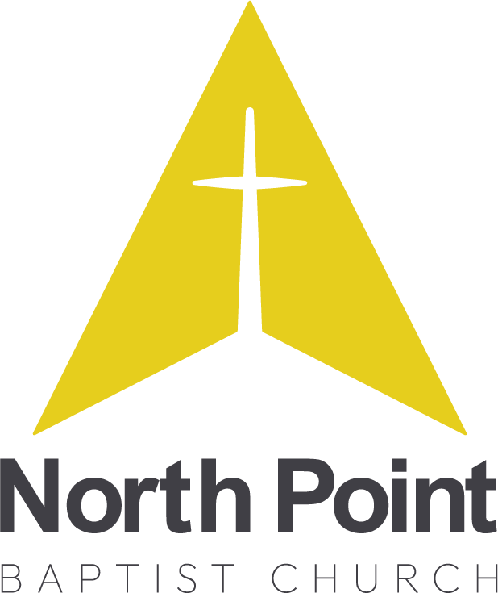
AM Core Seminars—War of Words
Part Two: A New Agenda for our Talk
Class 8: Getting to the Destination

- Recap
- Question

- INTRODUCTION
- Hope.

- PRACTICAL STEPS TO GET TO THE DESTINATION
  - Don’t give in to regret

  - Embrace gospel hope

  - Examine your fruit

  - Uncover your roots

  - Seek forgiveness

  - Freely grant forgiveness

  - Change the rules

  - A new commitment

  - Look for opportunities

  - Choose your words

  - Confess your weakness

  - Don't give the devil an opportunity

- Speaking out of hope

- Conclusion

Getting Personal: getting to the destination
- Where have you been tempted to believe Satan’s discouraging lies? (“He/she/they’ll never change! It is impossible to forgive him/her/them after the horrible things they’ve said. God doesn’t really care about your communication; he has better, more important things to do. Your anger really isn’t your fault. If others lived where you do, they would be angry too! Being humble just gives people an opportunity to take advantage of you”, etc.)
- What communication regrets do you need to leave behind? What “if onlys” have gotten in the way of the change to which God has called you?
- What specific verbal sins do you need to confess? To whom?
- Which God’s promises do you need to remember daily so that you will have hope in the midst of the struggle?
- Where do you need to start right now, as you seek to cooperate with God who is willing and able to restore your world of talk? What immediate changes is he calling you to?

